SIMATS ENGINEERING
ASSESSMENT TOOL 3 – CLASS TEST
Course Name: Internet Programming | Course Code: CSA4308
COURSE OUTCOME COVERED
CO 4: Formulate data-driven web solutions using XML, XSLT, and JSP within the MVC framework. (L4)
Assessment Tool: Class Test
Weightage: 10% Total Marks: 20
Question 1
Explain the fundamental concepts used in web development by defining the following terms with suitable explanations: XML, JSP, MVC architecture, XSLT, XML Schema, JSTL, PHP, Database Connectivity, and Parser. Your answer should clearly describe the purpose and role of each concept in web applications.
1. XML (eXtensible Markup Language)
XML is a markup language designed to store and transport structured data in a human-readable, platform-independent, self-descriptive text format, using custom user-defined tags rather than a fixed tag set (unlike HTML, which only describes how to display data). Purpose/role: XML acts as a universal format for exchanging data between different systems, applications, and platforms — e.g., a web application might use XML to represent a product catalog or configuration data that any programming language can read and process consistently.
2. JSP (JavaServer Pages)
JSP is a server-side technology that allows developers to embed Java code directly within HTML pages using special tags (scriptlets, expressions, directives) to generate dynamic web content. When a JSP page is first requested, the server translates it into a Java Servlet and compiles it, after which it executes like any other servlet. Purpose/role: JSP separates presentation (HTML) from the underlying logic needed to produce dynamic, data-driven pages — such as displaying a personalized list of products fetched from a database — making it central to building interactive, server-rendered web applications on the Java platform.
3. MVC Architecture (Model–View–Controller)
MVC is a software design pattern that divides a web application into three interconnected components: the Model (manages data and business logic, typically interacting with the database), the View (handles presentation — what the user actually sees, such as a JSP or PHP page), and the Controller (receives user requests, coordinates between the Model and View, and decides what response to send back). Purpose/role: By separating these concerns, MVC makes large web applications easier to develop, test, and maintain, since changes to the visual layout (View) don't require touching the business logic (Model), and vice versa.
4. XSLT (eXtensible Stylesheet Language Transformations)
XSLT is a language used specifically to transform XML documents into other formats — such as HTML for browser display, plain text, or even a different XML structure — by applying a set of template rules defined in an XSLT stylesheet. Purpose/role: In a web application, XSLT lets raw structured XML data (e.g., from a data feed or API) be automatically converted into a nicely formatted, styled web page, avoiding the need to manually rewrite the same data into HTML for presentation.
5. XML Schema (XSD)
An XML Schema (commonly an XSD file) defines the legal structure, data types, and constraints that a given category of XML documents must follow — specifying which elements and attributes are allowed, their order, data types (e.g., integer, string, date), and whether they are required or optional. Purpose/role: It allows an application to validate incoming or outgoing XML data programmatically before processing it, catching structurally invalid or malformed data early and ensuring reliable, predictable data exchange between systems.
6. JSTL (JSP Standard Tag Library)
JSTL is a collection of predefined, reusable tags that can be used inside JSP pages to perform common tasks — such as loops, conditionals, formatting, and database access — without writing raw embedded Java scriptlet code. Purpose/role: JSTL promotes cleaner, more maintainable JSP pages by keeping Java logic out of the HTML markup as much as possible, making pages easier for web designers (who may not know Java) to read and edit, while still supporting dynamic content generation.
7. PHP (Hypertext Preprocessor)
PHP is a widely-used, open-source server-side scripting language specifically designed for web development, allowing code to be embedded directly within HTML pages and executed on the server before the resulting page is sent to the client's browser. Purpose/role: PHP is used to generate dynamic page content, handle form submissions, manage sessions and cookies, and interact with databases — making it one of the most common technologies (alongside JSP) for building the server-side logic of data-driven websites.
8. Database Connectivity
Database connectivity refers to the mechanisms and APIs (such as JDBC — Java Database Connectivity — for Java applications, or MySQLi/PDO for PHP) that allow a web application's server-side code to establish a connection with a database, send SQL queries, and retrieve or modify stored data. Purpose/role: It forms the essential bridge between the application logic (Model, in MVC terms) and the persistent data store, enabling features like user authentication, product listings, or order histories to be dynamically read from and written to a database rather than hardcoded.
9. Parser
A parser is a software component that reads a document (commonly XML or HTML) and breaks it down into a structured, in-memory representation that a program can navigate and manipulate — common XML parsing approaches include DOM (Document Object Model, which loads the entire document into a tree structure in memory) and SAX (Simple API for XML, which reads the document sequentially/event-based without loading it entirely into memory). Purpose/role: Parsers make it possible for an application to actually read, extract, and process the data contained in XML (or HTML) documents, forming the foundation on which technologies like XSLT transformations and XML Schema validation operate.
Question 2
Explain how the above technologies are interconnected in building a web application. Describe how XML is structured and validated, how JSP and PHP are used for server-side processing, how MVC architecture organizes the application, and how database connectivity and parsers contribute to data processing and communication.
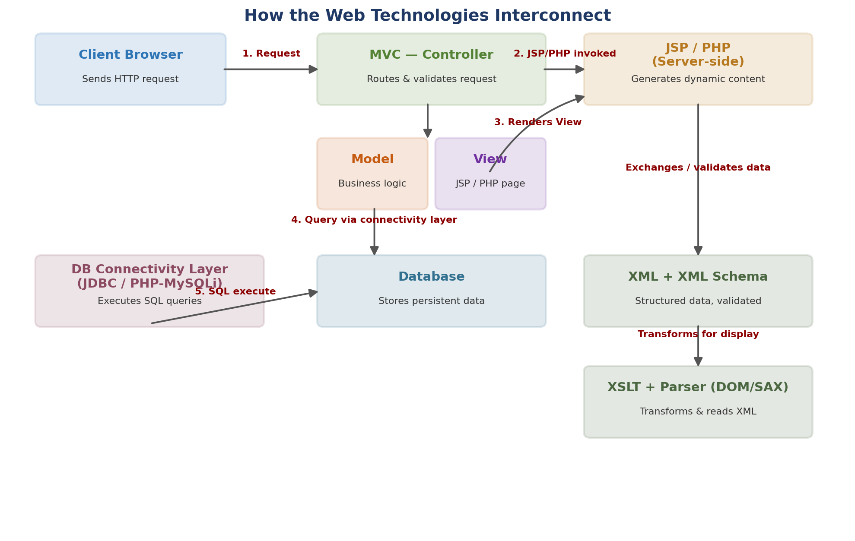
Figure 1: How XML, MVC, JSP/PHP, database connectivity, and XML tooling work together in a typical web application.
1. How XML Is Structured and Validated
XML data used within the application is first structured according to a defined hierarchy of custom tags representing the application's data (e.g., a <products> root element containing multiple <product> child elements, each with <name>, <price>, and <stock> sub-elements). Before this XML is trusted and processed further, it is validated against an XML Schema (XSD), which checks that the document follows the required structure, element ordering, and data types. Only once a parser confirms the document is both well-formed (correct XML syntax) and valid (conforms to the schema) does the application proceed to use the data — this validation step is what allows XML to serve as a reliable data-exchange format between different parts of the system, or between the application and external partners/APIs.
2. How JSP and PHP Handle Server-Side Processing
Once a request reaches the server, JSP (on the Java platform) or PHP (on the PHP platform) is responsible for the server-side processing that produces the actual dynamic content the user sees. Both embed executable code directly alongside HTML markup: JSP uses scriptlets/expressions (often replaced with cleaner JSTL tags in well-structured applications) compiled into a servlet, while PHP is interpreted directly on each request. In both cases, this server-side layer is where form input is read, business rules are applied, session state is managed, and — critically — where the application reaches out to the database via the connectivity layer to fetch or store the data needed to build the response page.
3. How MVC Architecture Organizes the Application
MVC provides the overall structural framework that ties everything else together. The Controller is the entry point for every incoming request, deciding what needs to happen and delegating actual data work to the Model. The Model performs the business logic and is the layer that actually talks to the database (through the connectivity layer) and/or reads and validates XML data. Once the Model has prepared the required data, the Controller passes it to the View — typically implemented as a JSP or PHP page — whose sole responsibility is to render that data into the final HTML sent back to the browser. This separation is what allows JSP/PHP (View), business rules (Model), and request handling (Controller) to evolve independently without one layer's changes breaking another.
4. How Database Connectivity and Parsers Contribute to Data Processing
Database connectivity (e.g., JDBC for JSP/Java, or MySQLi/PDO for PHP) is the mechanism the Model uses to communicate with the underlying relational database — opening a connection, executing SQL queries, and retrieving result sets that are then converted into objects or arrays the rest of the application can use. In parallel, when the application needs to work with XML data — whether from an external API, a configuration file, or a data feed — a parser (DOM or SAX) is what actually reads that XML into a usable in-memory structure, and XSLT can then be applied to transform that structured XML into presentable HTML if needed. Together, database connectivity handles structured relational data, while parsers and XSLT handle structured document/XML data, and both ultimately feed processed data into the Model layer of the MVC application, which the Controller and View then turn into the final response delivered to the client.
5. Summary of the Full Interconnection
- Client sends a request → received by the Controller (MVC).
- Controller delegates to the Model, which uses Database Connectivity (JDBC/MySQLi) to query the database, and/or a Parser + XML Schema to read and validate any XML data involved.
- If XML data needs to be presented, XSLT transforms it into HTML-ready content.
- The Model returns processed data to the Controller, which passes it to the View.
- The View — built with JSP (using JSTL for clean dynamic content) or PHP — renders the final HTML response, which is sent back to the client browser.
This layered, interconnected flow is what allows a modern web application to cleanly separate structured data (XML), server-side processing (JSP/PHP), persistent storage (databases via connectivity), and application structure (MVC) into a maintainable, data-driven system.
Code of Conduct:
I K. Sai Kumar(192372080)(Name / Reg No) certify that this submission is my original work and that I have adhered to the guidelines specified for this assessment. I understand that any violation of academic integrity rules will result in disciplinary action.
Signature of the student: ______________________
RUBRICS FOR CALCULATION
Criteria | Weightage | Level 4 – Exemplary | Level 3 – Proficient | Level 2 – Developing | Level 1 – Beginning
Concept Understanding | 25% | Clearly explains all concepts with complete accuracy and depth | Minor gaps in understanding | Basic understanding with some errors | Incorrect or very limited understanding
Content Coverage | 25% | Covers all required topics comprehensively | Covers most topics with minor omissions | Covers some topics only | Very few topics covered
Technical Accuracy | 20% | All explanations are technically correct and precise | Minor technical errors | Some incorrect or vague explanations | Major technical errors
Integration of Concepts | 15% | Effectively connects and relates concepts logically | Some connections made with minor gaps | Limited connections between concepts | No clear relationship between concepts
Clarity & Presentation | 15% | Well-structured, clear, and easy to understand | Mostly clear with minor issues | Somewhat unclear or poorly organized | Poorly structured and difficult to understand

